PING SIMULATION

EXPT.NO: 4
AIM: To perform ping to a remote host, extract RTT values from ping response and compute the minimum, maximum and average Round Trip Time.
ALGORITHM:
- Run the ping command using python’s subprocess module.
- Capture the output of each ping reply.
- Extract RTT values using regex or string passing.
- Store all RTTs in a list.
- Calculate and display:
- Minimum RTT
- Maximum RTT
- Average RTT
CODE:
import socket, time
host = "google.com"
port = 80
count = 4
times = []

for i in range(count):
try:
s = socket.socket()
start = time.time()
s.connect((host, port))
end = time.time()
s.close()
rtt = (end - start) * 1000
times.append(rtt)
print(f"Reply from {host}: time={rtt:.2f} ms")
except:
print("Request timed out")
if times:
print("\nMin RTT =", min(times), "ms")
print("Max RTT =", max(times), "ms")
print("Avg RTT =", sum(times)/len(times), "ms")

INPUT:
Destination host: google.com
Number of pings: 5
OUTPUT:
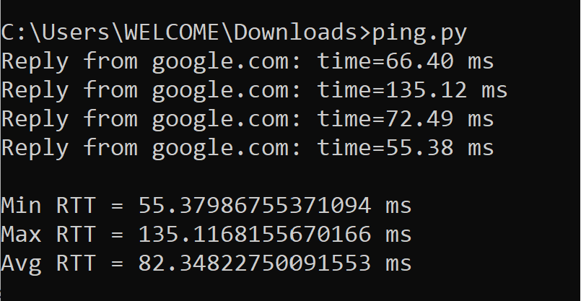

RESULT:
The program successfully performed ping operation (google.com, extracted RTT values from the response and compute the minimum, maximum and average RTT.

